Web Technology Assignment - lab 6 Name- Telange Khandeshwar

Roll no.- 22IT3058

Simple Prototype

Q1. <!DOCTYPE html>

<html lang="en">

<head>

<meta charset="UTF-8">

<meta name="viewport" content="width=device-width, initial-scale=1.0">

<title>Simple Shopping List</title>

</head>

<body>

<h1>Shopping List</h1>

<input type="text" id="itemInput" placeholder="Enter item"> <button onclick="addItem()">Add</button>

<ul id="itemList"></ul>

<script>

function addItem() {

var input = document.getElementById("itemInput"); var item = input.value;

if (item === '') return;

var itemList = document.getElementById("itemList"); var li = document.createElement("li");

li.appendChild(document.createTextNode(item)); itemList.appendChild(li);

input.value = '';

}

</script>

</body>

</html>

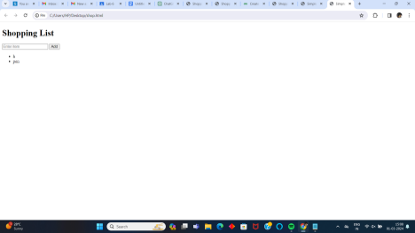By using MVC Prototype

<!DOCTYPE html>

<html lang="en">

<head>

<meta charset="UTF-8">

<meta name="viewport" content="width=device-width, initial-scale=1.0">

<title>Shopping List</title>

<style>

body {

font-family: Arial, sans-serif;

}

h1 {

text-align: center;

}

input[type="text"] {

padding: 8px;

width: 60%;

margin: 10px auto;

display: block;

border: 1px solid #ccc;

border-radius: 5px;

}

button {

padding: 8px 16px;

background-color: #007bff;

color: #fff;

border: none;

border-radius: 5px;

cursor: pointer;

}

button:hover {

background-color:

#0056b3; }

ul {

list-style-type: none;

padding: 0;

margin: 20px auto;

width: 60%;

background-color: #fff;

border-radius: 5px;

box-shadow: 0 2px 5px rgba(0,0,0,0.1); }

li {

padding: 10px;

border-bottom: 1px solid #ccc;

}

</style>

</head>

<body>

<h1>Shopping List</h1>

<input type="text" id="itemInput" placeholder="Enter item"> <button onclick="controller.addItem()">Add</button> <ul id="itemList"></ul>

<script>

var model = {

items: [],

addItem: function(item) {

this.items.push(item);

view.render();

},

getItems: function() {

return this.items;

}

};

var view = {

render: function() {

var itemList = document.getElementById("itemList"); itemList.innerHTML = '';

var items = model.getItems();

items.forEach(function(item) {

var li = document.createElement("li");

li.textContent = item;

itemList.appendChild(li);

});

}

};

var controller = {

addItem: function() {

var input = document.getElementById("itemInput");

var item = input.value.trim();

if (item === '') return;

model.addItem(item);

input.value = '';

}

};

window.onload = function() {

view.render();

};

</script>

</body>

</html>

